**Clapping your hands**

# 1. Learning goals

In this lesson, we will learn to use the micro:bit on board microphone. When we clap our hands, the heart pattern on the dot matrix will beat.

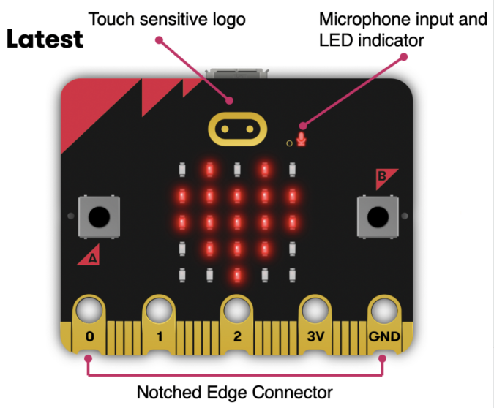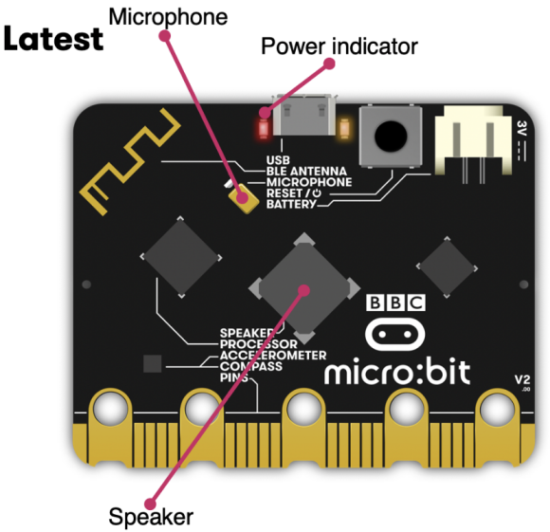

1. **Mode 1 online programming:**

First, we need to connect the micro:bit to the computer by USB cable. The computer will pop up a USB flash drive and click on the URL http://microbit.org/ in the USB flash drive to enter the programming interface to start program.

**Mode 2 offline programming:**

We need to open the offline programming software. After the installation is complete, enter the programming interface, click【New Project】, you can start program.

**3.Looking for blocks**

The following is the location of the building blocks required for this programming.

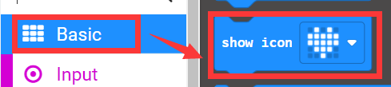

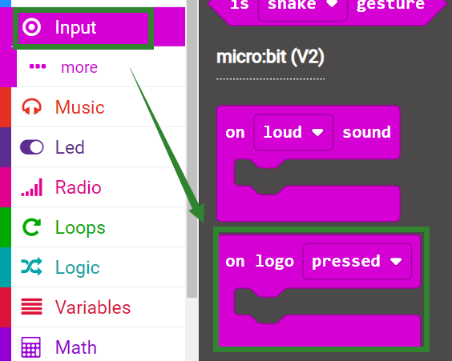

**4.Combine block**

The summary program is shown below.

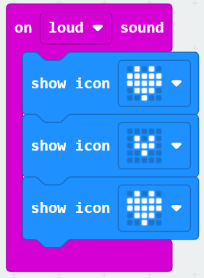

Whenever the Micro:bit board detects a sound input, the heart-shaped pattern of the dot matrix will change to form the effect of heart beating.

**5.Experimental phenomena**

After connecting the computer to the micro:bit board via the micro USB data cable. Click download or save on the programming interface, and the program can be successfully downloaded to the Micro:bit board.

After the program is downloaded successfully, the micro:bit dot matrix does not display anything, but the microphone indicator on the board is always on, indicating that the sound value is now being obtained.

At this time, we need to clap our hands to make a sound to the microphone. The heart pattern will be displayed.

!Tips:

The microphone indicator on the motherboard will always be on when the microphone-related code is used. As shown below.

